STREAMLINING TICKET ASSIGNMENT FOR EFFICIENT SUPPORT OPERATIONS

A Naan Mudhalvan Project Report Submitted To
BHARATHIDASAN UNIVERSITY, TIRUCHIRAPPPALLI
In Partial Fulfillment of the Requirements of the Award of the Degree of
BACHELOR OF COMPUTER SCIENCE
Submitted by
NAME: REG NO:
SANJAY.S 23051791802111020
HARIHARAN.S 23051791802111017
VINOTHKUMAR.P 23051791802111022
GOBIKA.S 23051791802112007
RAGAVI.R 23051791802112012

Under The Guidance of
Miss. R. SRIMATHI .MCA
(Assistant Professor of Computer Science)

UNDER GRADUATE DEPARTMENT OF COMPUTER SCIENCE
IMAYAM ARTS AND SCIENCE COLLEGE
KANNANUR-621206, THURAIYUR.
MARCH-2026

SIGNATURE OF THE FTP: SIGNATURE OF THE EXTERNAL:

Streamlining Ticket Assignment for Efficient Support Operation

Introduction:
Streamlining ticket assignment is a foundational element in modern, efficient support operations, transforming how customer inquiries are managed, routed, and resolved. As customer expectations for speed and accuracy rise, traditional, manual, or ad-hoc ticket allocation methods often become bottlenecks, leading to increased response times, agent burnout, and decreased customer satisfaction. By automating this process, organizations can ensure that every incoming request—whether via email, chat, or social media—is instantly analyzed and routed to the most appropriate, available agent, significantly reducing the "back-and-forth" that frustrates customers. An effective, streamlined system leverages intelligent automation to move beyond simple, manual sorting, utilizing techniques such as skill-based routing, round-robin assignment, and priority-based filtering.
Problem statement:
ABC Corporation, a leading technology company, was facing challenges with efficiently assigning support tickets to the appropriate teams. With a vast array of products and services , the support team found it increasingly difficult to manually route tickets to the right groups, leading to delays in issue resolution and customer dissatisfaction.

Objective:

The objective of this initiative is to implement an automated system for ticket routing at ABC Corporation, aimed at improving operational efficiency by accurately assigning support tickets to the appropriate teams. This solution aims to reduce delays in issue resolution, enhance customer satisfaction, and optimize resource utilization within the support department.

TASKINITIATION

Milestone1:Users

Activity1:CreateUsers
- Open service now.
- Click on All>> search for users
- Select Users under system security
- Click on new

- Fill the following details to create a new user
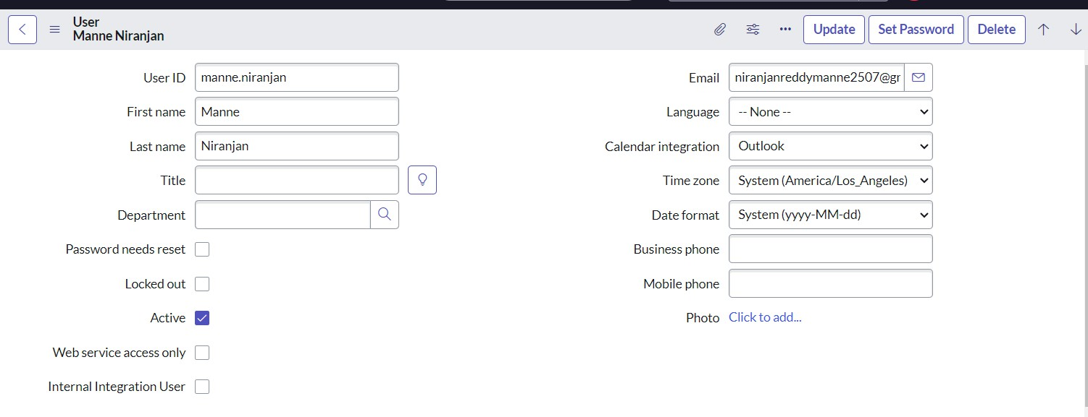
- Click on submit

Create one more user:
- Create another user with the following details
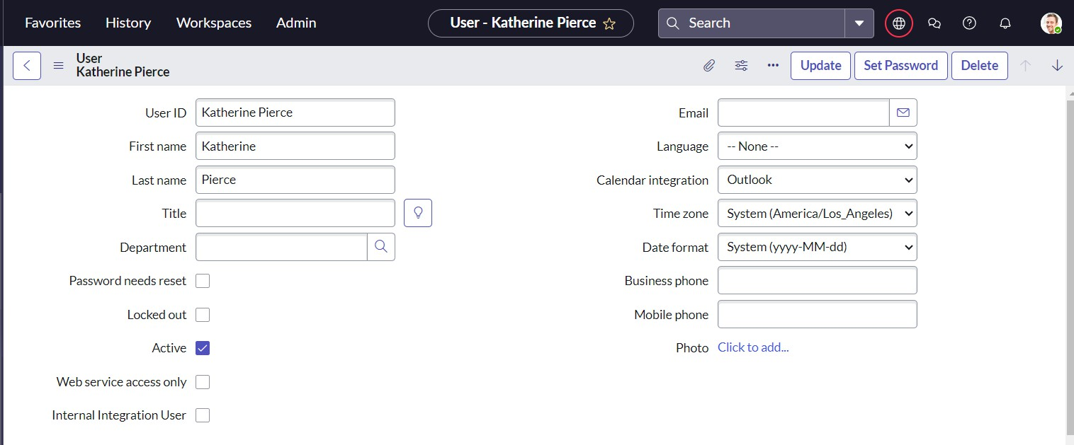
- Click on submit

Milestone2:Groups

Activity1:CreateGroups

- Open service now
2. Click on All>> search for groups
- Select groups under system security
- Click on new
- Fill the following details to create a new group
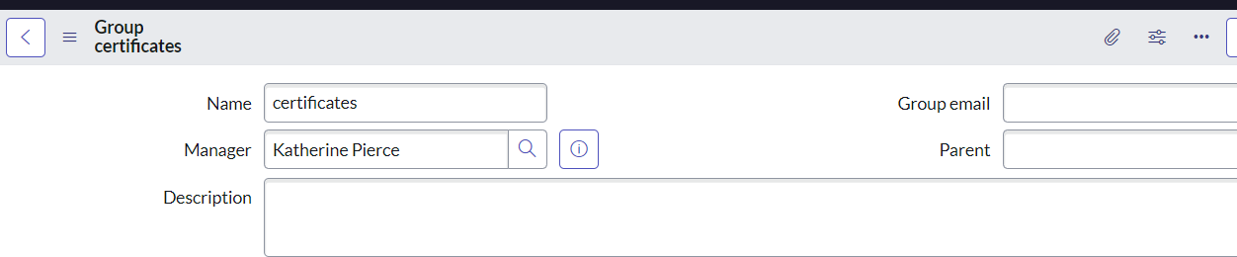
- Click on submit

Create one more group:

- Create another group with the following details
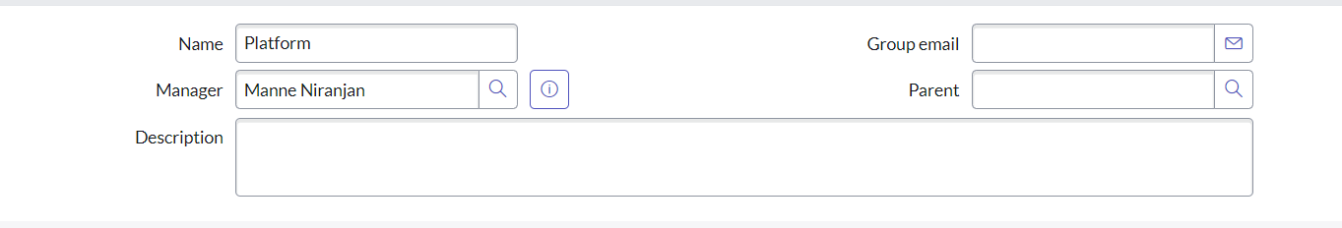
- Click on submit

Milestone 3 : Roles Activity1:Createroles
- Openservice now.
- Click on All>> search for roles
- Select roles under system security
- Click on new
- Fill the following details to create a new role
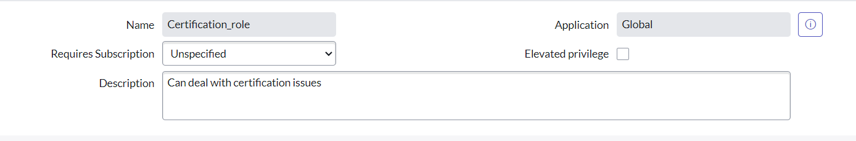
- Click on submit

Create one more role:

Create another role with the following details

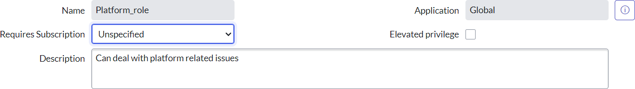
Click on submit

Milestone4:Table

Activity1:CreateTable

- Open service now.
- Click on All>> search for tables
- Select tables under system definition
- Click on new
- Fill the following details to create a new table Label : Operations related
Check the boxes Create module & Create mobile module
- Under new menu name : Operations related
- Under table columns give the columns
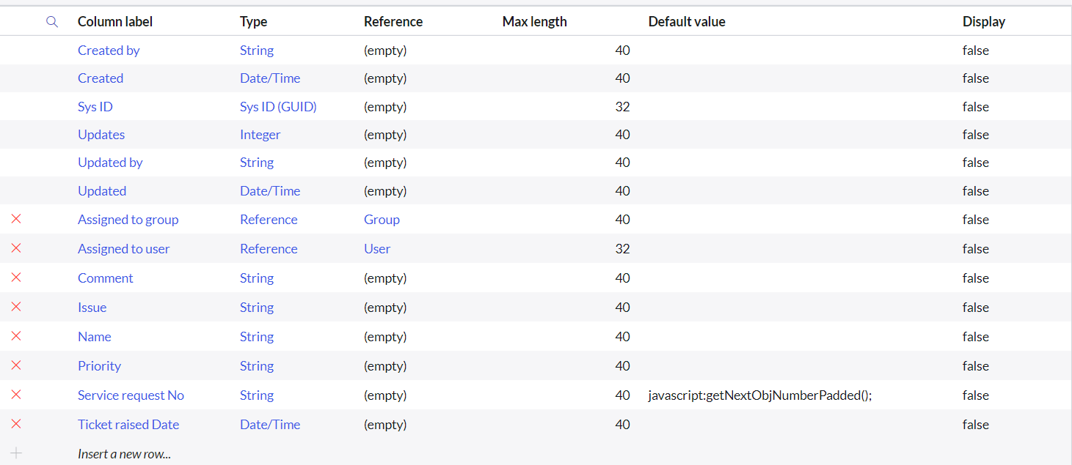
- Click on submit

- Create choices for the issue filed by using form design Choices are
Unable to login to platform 404 error
regarding certificates regarding user expired

Milestone5:Assignroles&userstogroups

Activity1:Assignroles&userstocertificategroup
- Open service now.
- Click on All>> search for tables
- Select tables under system definition
- Select the certificates group
- Under group members
- Click on edit
- Select Katherine Pierce and save
- Click on roles
- Select Certification role and save

Activity2:Assignroles&userstoplatformgroup
- Open service now.
- Click on All>> search for tables
- Select tables under system definition
- Select the platform group
- Under group members
- Click on edit
- Select Manne Niranjan and save
- Click on roles
- Select Platform role and save

Milestone6:Assignroletotable
- Open service now.
- Click on All>> search for tables
- Select operations related table
- Click on the Application Access
- Click on u operations related read operation
- Click on the profile on to right side
- Click one levate role
- Click on security admin and click on update
- Under Require role
- Double click on insert a new row
- Give plat form role
- And add certificate role
- Click on update
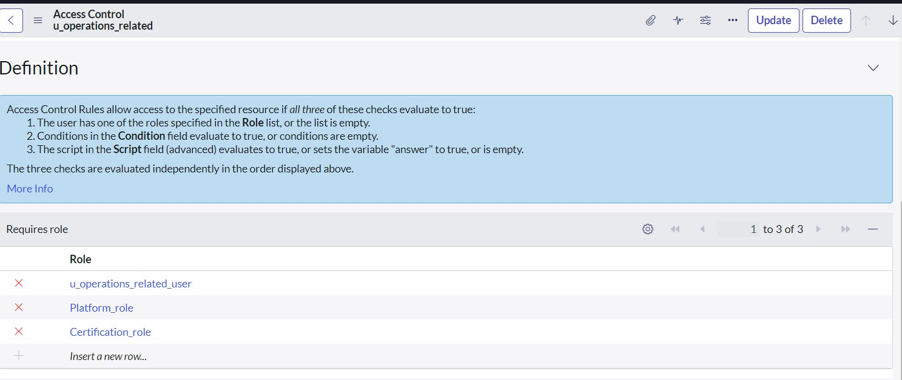
- Click on u operations related write operation
- Under Requires role
- Double click on insert a new row
- Give plat form role
- And add certificate role

Milestone7:Create ACL
- Open service now.
- Click on All>> search for ACL
- Select Access Control(ACL) under system security
- Click on new

- Fill the following details to create a new ACL
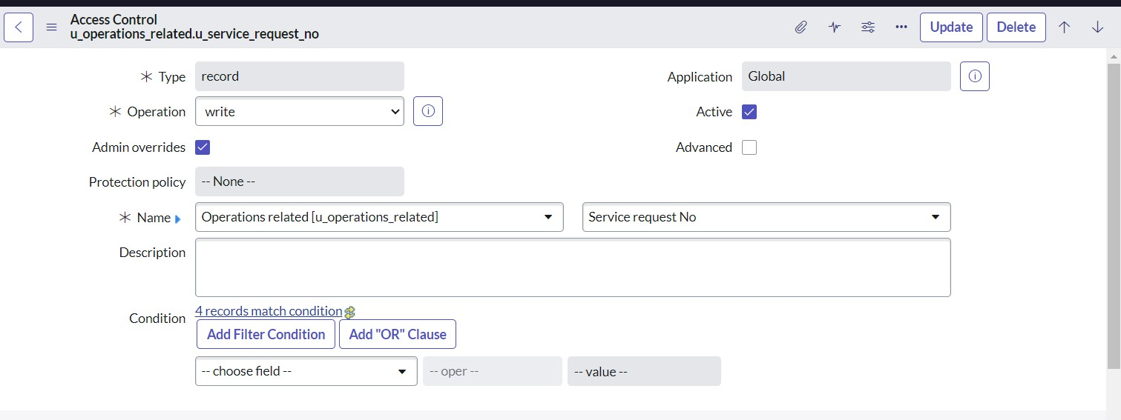
- Scroll down under requires role
- Double click on insert a new row
- Give admin role
- Click on submit
- Similarly create 4 acl for the following fields
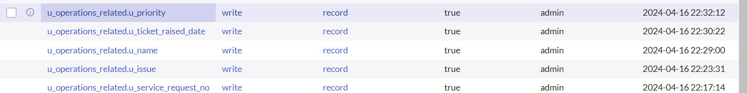

Milestone8:Flow

Activity1:CreateaFlowtoAssignoperationstickettogroup
- Open service now.
- Click on All>> search for Flow Designer
- Click on Flow Designer under Process Automation.
- After opening Flow Designer Click on new and select Flow.
- Under Flow properties Give Flow Name as “ Regarding Certificate”.
- Application should be Global.
- Select Run user as “ System user ” from that choice.
- Click on Submit.

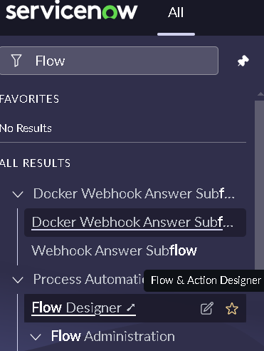
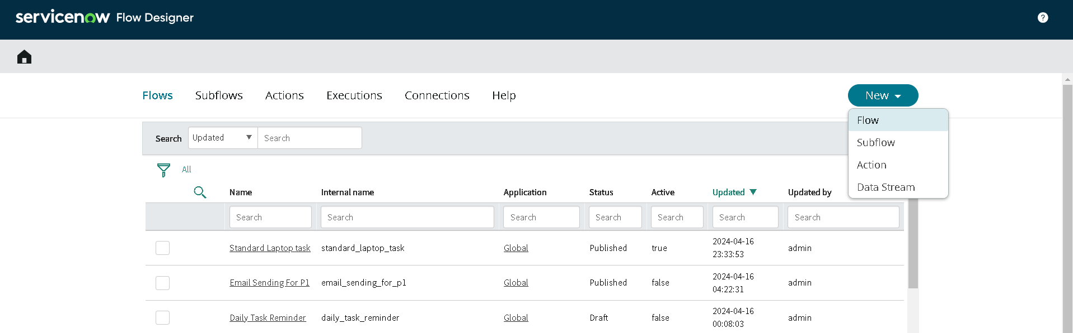

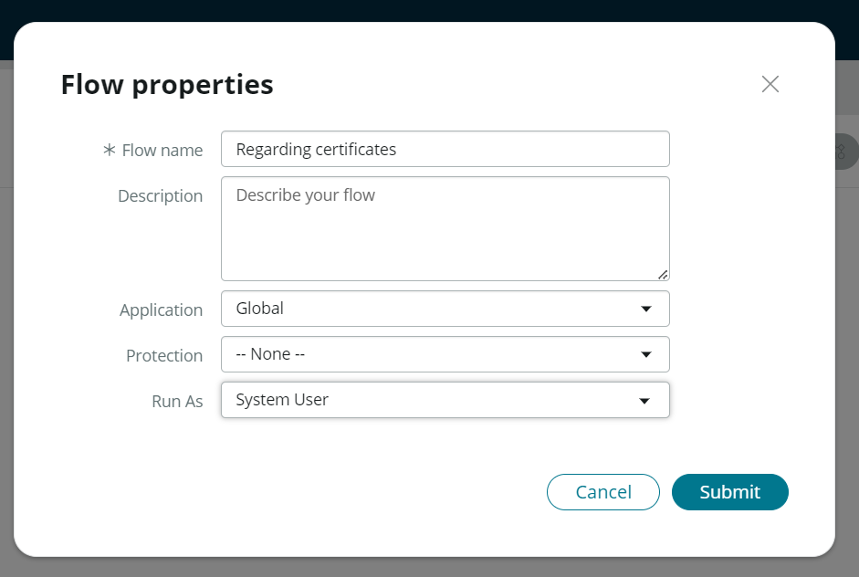

- Click on Add a trigger
- Select the trigger in that Search for “create or update a record” and select that.
- Give the table name as “ Operations related ”.
- Give the Condition as Field : issue
Operator : is
Value: Regrading Certificates
- After that click on Done.

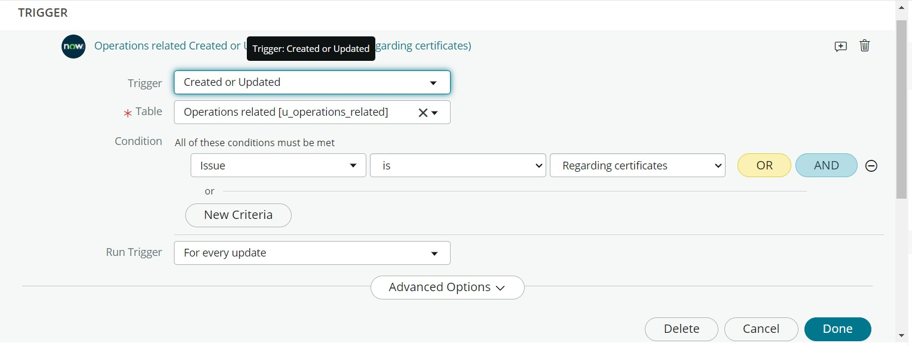
- Now under Actions.
- Click on Add an action.
- Select action in that search for “ Update Record ”.
- In Record field drag the fields from the data navigation from left side
- Table will beau to assigned after that
- Give the field as “ Assigned to group ”
- Give value as “ Certificates ”
- Click on Done.
- Click on Save to save the Flow.
- Click on Activate.
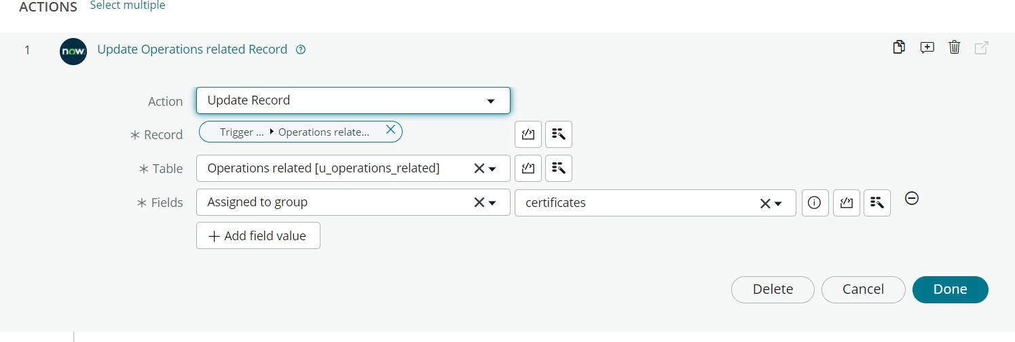

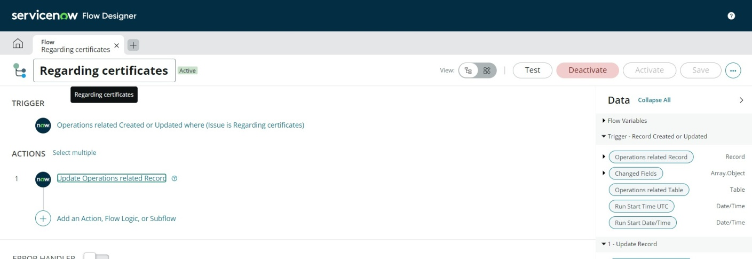

Activity2:CreateaFlowtoAssignoperationstickettoPlatformgroup

- Open service now.
- Click on All>> search for Flow Designer
- Click on Flow Designer under Process Automation.
- After opening Flow Designer Click on new and select Flow.
- Under Flow properties Give Flow Name as “ Regarding Platform ”.
- Application should be Global.
- Select Run user as “ System user ” from that choice.
- Click on Submit.

- Click on Add a trigger
- Select the trigger in that Search for “create or update a record ”and select that.
- Give the table name as “ Operations related ”.
- Give the Conditionas Field : issue
Operator : is
Value: Unable to login to platform

- Click on New Criteria Field : issue
Operator : is
Value:404Error

- Click on New Criteria Field : issue
Operator : is
Value: Regrading Userexpired

- After that click on Done.
- Now under Actions.
- Click on Add an action.
- Select action in that search for “ Update Record ”.
- In Record field drag the fields from the data navigation from left side
- Table will beauty assigned after that
- Give the field as “ Assigned to group ”.
- Give value as “ Platform ”.
- Click on Done.
- Click on Save to save the Flow.
- Click on Activate.

Conclusion :

The implementation of the automated ticket routing system at ABCC or poration has been a significant success. By leveraging the capabilities of ServiceNow,we have streamlined the process of assigning support tickets to the appropriate teams, addressing the challenges of manual routing, and ensuring timely resolution of issues.

